Applexus - Trainee Consultant (ABAP)

* Area: Academic projects, technologies, company
* ABAP is a programming language which can use to develop business applications in SAP environment
* Enterprise Resource Planning (ERP) = Systems Applications and Products (SAP)
* Enterprise Business Process

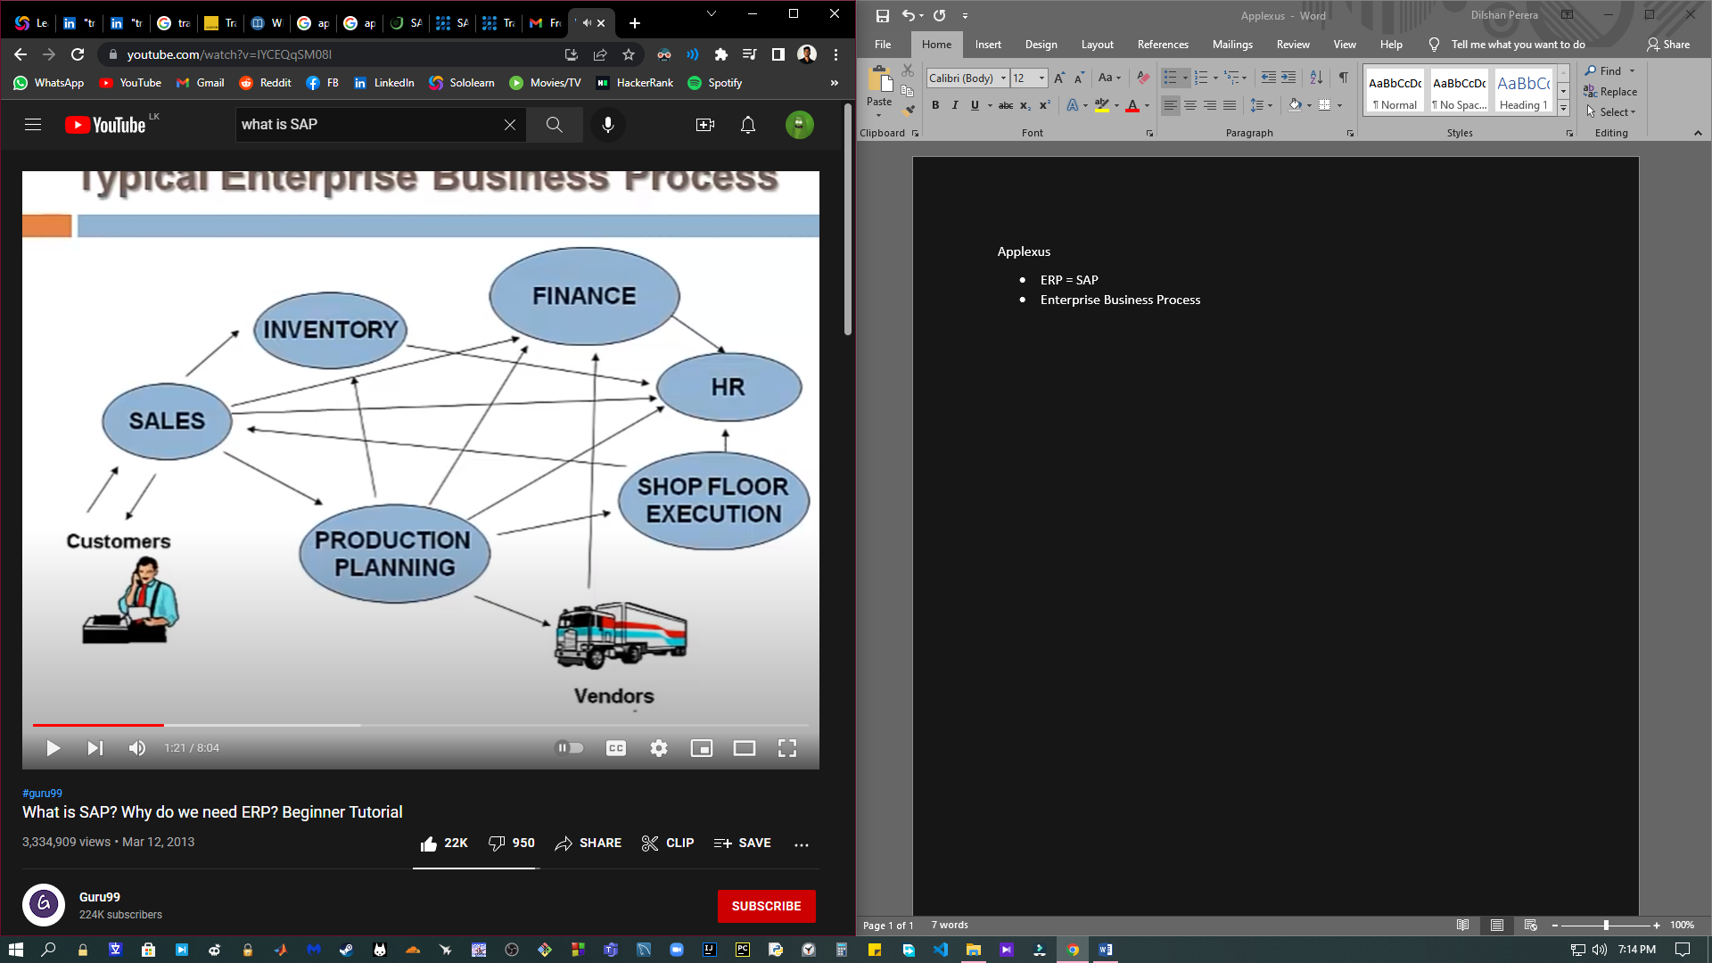

* Enterprise Software Systems
  + Decentralized Systems: Data managed at individual departments (BU). Depts don’t have access to other deptments

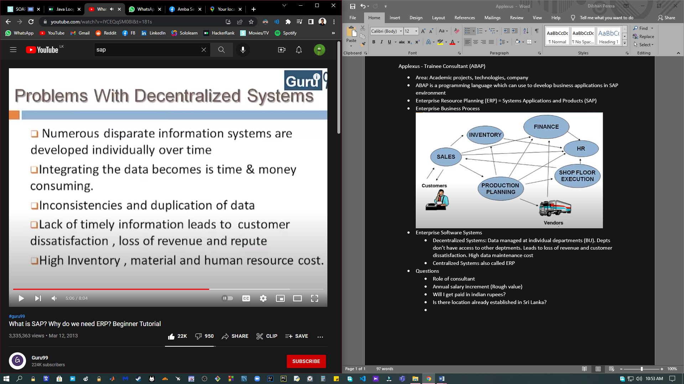

* + Centralized Systems also called SAP (Systems Applications and Products) or ERP (Enterprise Resource Planning)

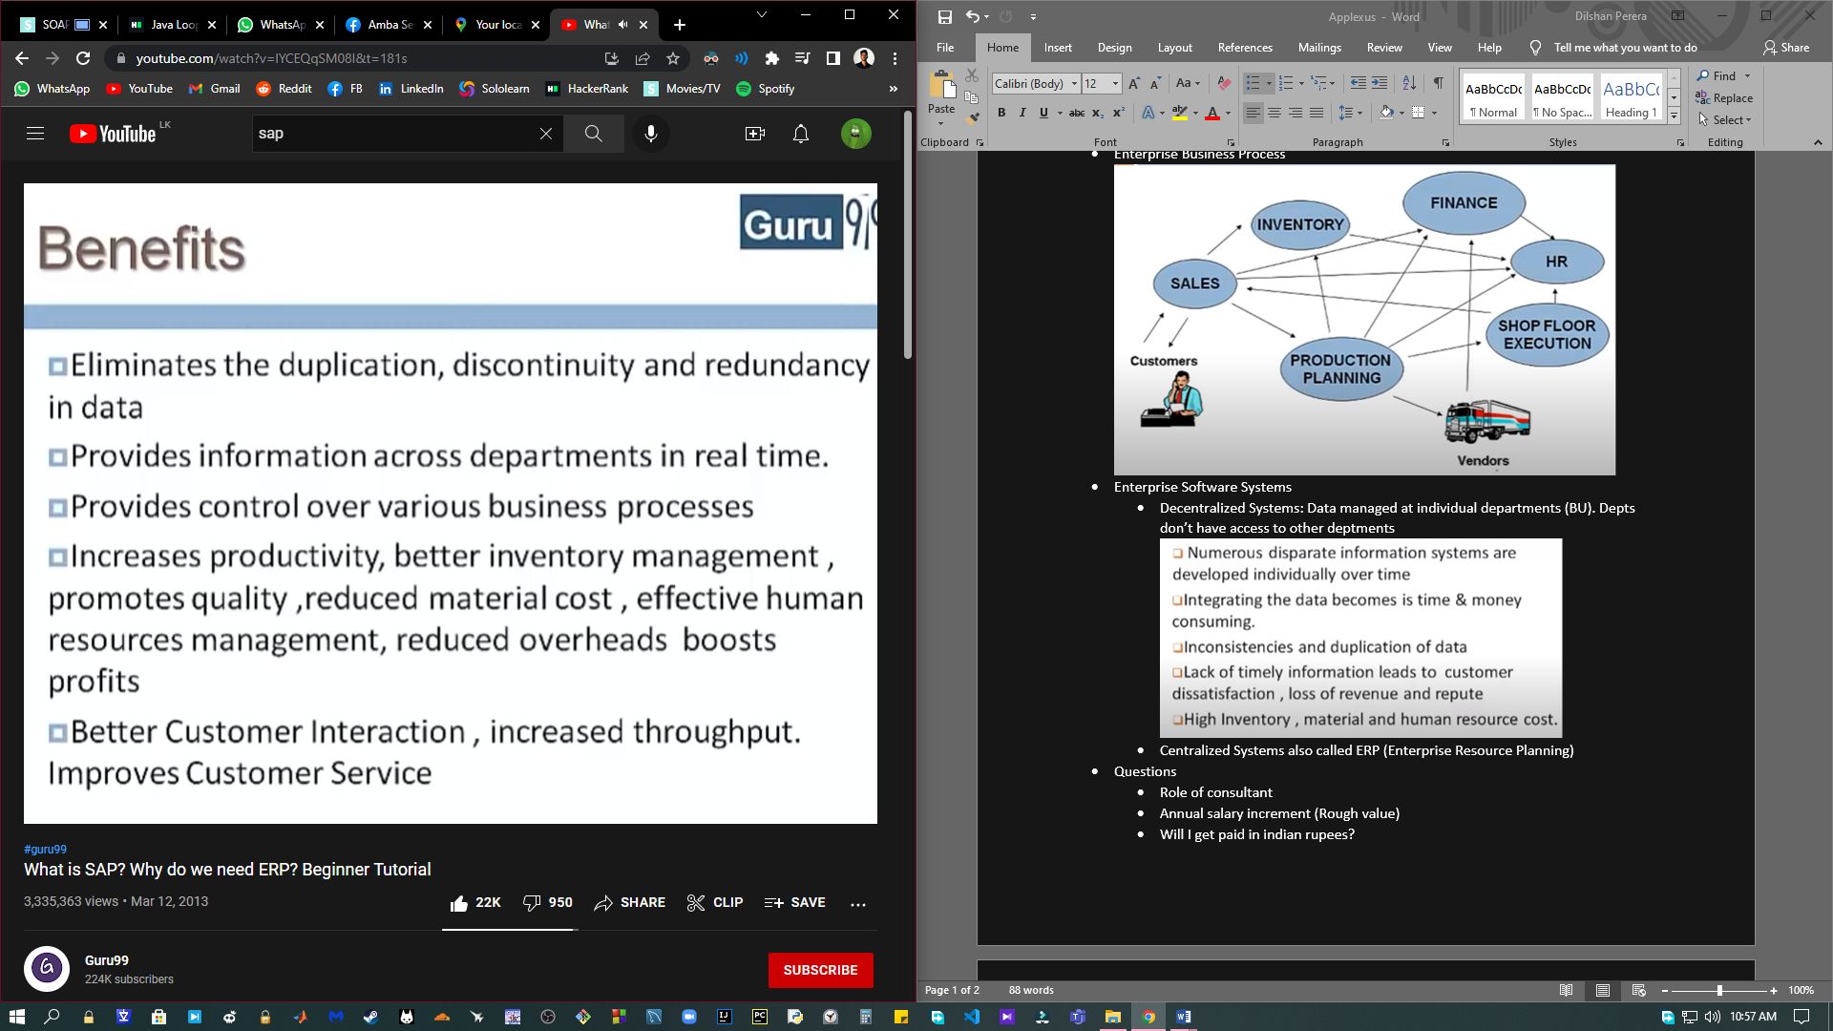

* API: Application Programming Interface
* ABAP: Advanced Business Application Programming
* OOP: Object Oriented Programming
  + Programming model that organizes software design aroud data or objects rather 4767365.05than functions and logic
  + Inheritance - Inheriting attributes and methods of another class
  + Encapsulation - Hides data from outside access
  + Polymorphism - Function having same name but carrying different functionalities
  + Data abstraction - Hiding internal details of a function and showing its functionality only
* Data class: A list of data set allocation attributes and their values
* HANA: High Performance Analytic Appliance
* R3 ABAP

Tell me about yourself

* I’m Dilshan Perera. I’m 25 years old. I went to Royal College, Colombo which is the leading boys’ school in Sri Lanka and did my ordinary level and advanced level exams there. I got 9As for my ordinary level exam and 2A and 1B for my advanced level exam. Then, I got selected to University of Moratuwa which is the leading technical university in Sri Lanka. I did bachelor degree there in Electrical Engineering. Later I decided that I’m going to change my career path to IT field and right now I have finished all my academic work and waiting for the convocation. I’m self studying and looking for opportunities to get my first hand experience in IT field while contributing my maximum for the company.